Applications of Derivatives

Finding the maximum or minimum of a function.
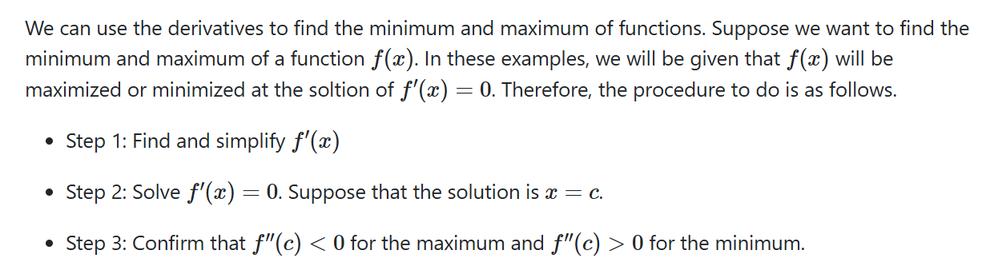

- Cost Function, Marginal Cost Function
The marginal cost represents the approximate cost of producing the next unit.

Example 1:

The per-day cost function of the manufacture of portable MP3 players is given by

C(x) = 128,000 + 30x + $x^{3}$

where x is the number of MP3 players manufactured per day. Assume that the company cannot manufacture more than 100 MP3 players per day.

- Find the marginal Cost function.
- Interpret the meaning of C’ (80).
- Find the actual cost of producing the 81st item.
- Write the average cost function
- How many MP3 players should be manufactured in order to minimize the average cost?

You try

The per-day cost function of the manufacture of portable MP3 players is given by

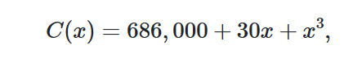

where x is the number of MP3 players manufactured per day. Assume that the company cannot manufacture more than 100 MP3 players per day.
a. Find the marginal Cost function.
b. Interpret the meaning of C’ (80).
c. Find the actual cost of producing the 81st item.
d. Write the average cost function
e. How many MP3 players should be manufactured in order to minimize the average cost?

- Revenue Function and Marginal Revenue Function
It represents the approximate additional income gained from selling the next unit.

Example
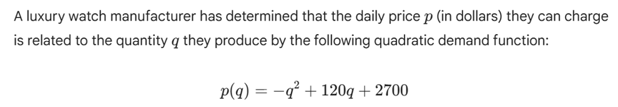
- Find the revenue function and the marginal revenue function
- Interpret the meaning of MR (10).
- Find the actual revenue of selling the 11st item.

- Find the quantity to maximize the revenue function

You try


- Find the revenue function and the marginal revenue function
- Interpret the meaning of MR (10).
- Find the actual revenue of selling the 11st item.
- Find the quantity to maximize the revenue function

- Profit function and Marginal Profit Function

It represents the approximate change in total profit from producing and selling the next unit.

Example

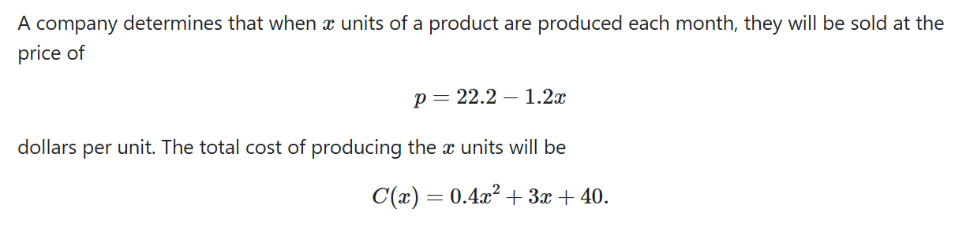

- Find the profit function and the marginal profit function
- Interpret the meaning of MP(5).
- Find the actual profit of selling the 6th item.

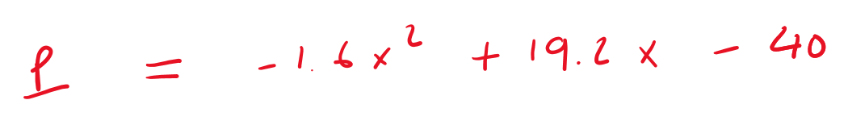
- How many units should the company produce to maximize the profit?

You try

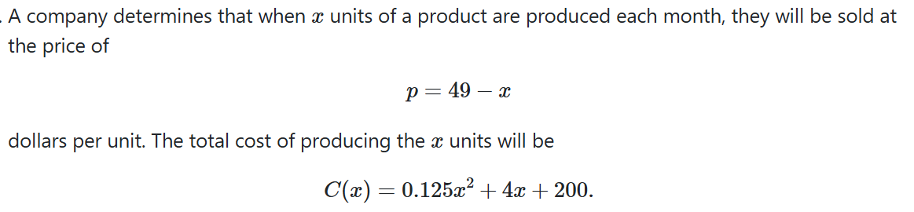

- Find the profit function and the marginal profit function
- Interpret the meaning of MR(5).
- Find the actual profit of selling the 6th item.
- How many units should the company produce to maximize the profit?

